The ngStyle Directive

In this lecture, we are going to explore another attribute directive called **ngStyle.**

**This directive allows us to dynamically bind CSS properties through these style attributes. The syntax for the ngStyle Directive is very similar to the ngClass Directive.**

**Its a great Directive for changing one or two properties on an element instead of applying an entire class.**

Let’s give it a try by changing the font size of the button in our template.

First, we should sore the font size in our components class:

Open the app component class:

Inside this class, we will create a property called **fontSize**, its value will be 16.

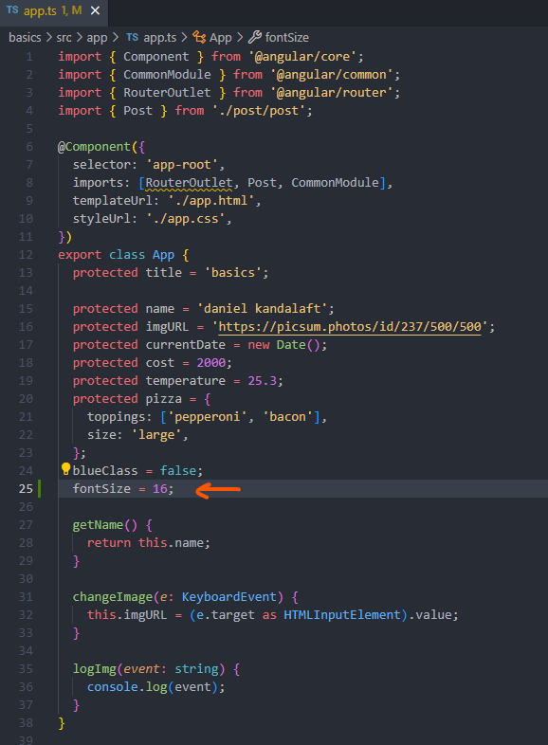

The next step, is to define this property to the button’s **font size** with the **ngStyle directive**.

Let’s open the app template file:

On the button, we will add the **ngStyle directive** with **property binding**, once again, we’re **binding the directive. By default, directive values are not interpreted as expressions, binding a directive will allow us to bind the value to properties in our class. Otherwise, we won’t be able to bind it to the font size property. We will pass in an object with the font-size CSS property. Notice how I’m formatting the name of the CSS property in the object.**

**Previously, we didn’t wrap the name with quotes in the ngClass Directive. However, the font-size property is multi-worded properties, for multi-worded properties, we need to wrap them with quotes. Next, let’s bind this CSS property to the font-size property in our class:**

**[ngStyle]=”{ ‘font-size’: fontSize }”**

**This solution won’t work yet.**

Keep in mind, we are modifying a CSS property. font-sizes must have a unit of measurement.

We have two options at our disposal.

We can add the measurement as a string or we can add it to the property.

Adding it to the property is the shorthand way of adding the measurement.

After the property name, we will add a dot, followed by the measurement:

**[ngStyle]=”{ ‘font-size.px’: fontSize }”**

Angular will append the unit of measurement to the value. There isn’t an advantage to using this syntax. It’s all preferences, in my opinion, it looks a whole lot cleaner than appending the measurement to the value as a string.

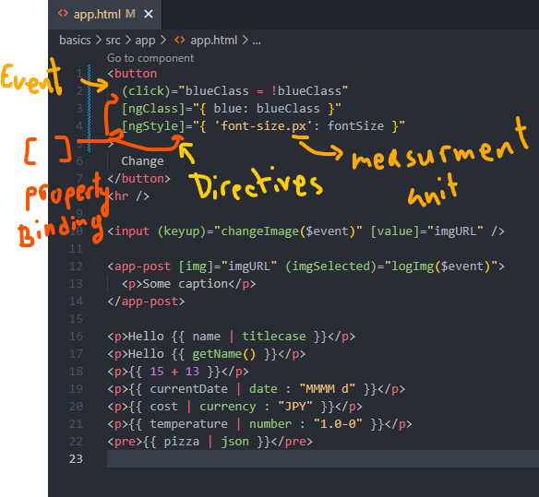

Let’s refresh the page:

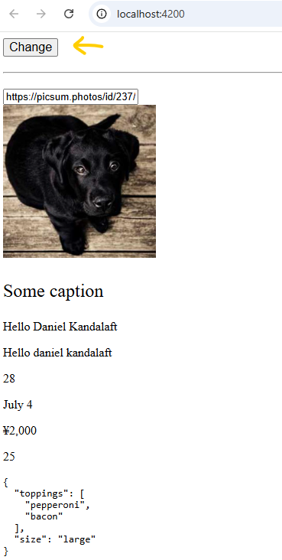

As you can see, the font-size for the button has increased. In our app, we don’t have a way to increase the font-size. Luckily, we don’t need to create such a feature. We can use the developer tools to verify if the directives are working as intended.

Open the Angular developer tools. Under the components section, Angular has added additional information about our components:

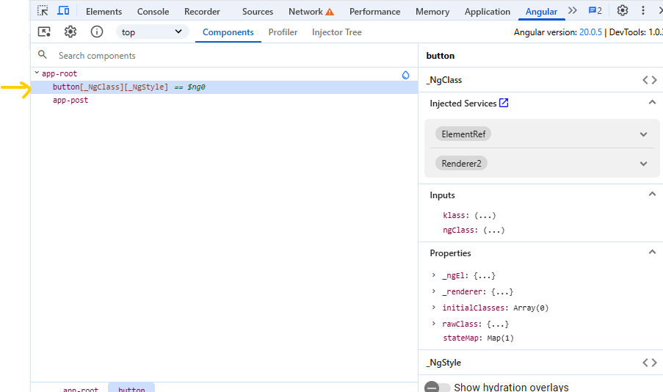

Previously, we would only see a list of components. However, the button element has been added to the list, despite our app component containing other elements. Angular will show us which directives are on the element If we apply directives to an element or component. Don’t be alarm if you find elements that aren’t components. It may have a directive on it.

In the component list, we will select the app component **app-root.** Next, we will modify the **font-size property:**

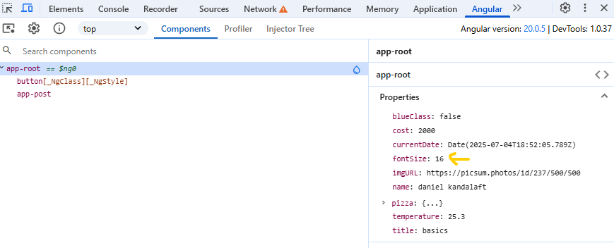

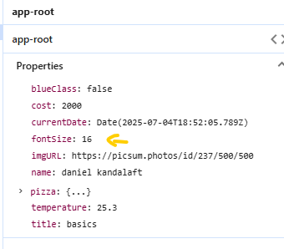

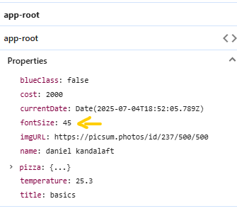

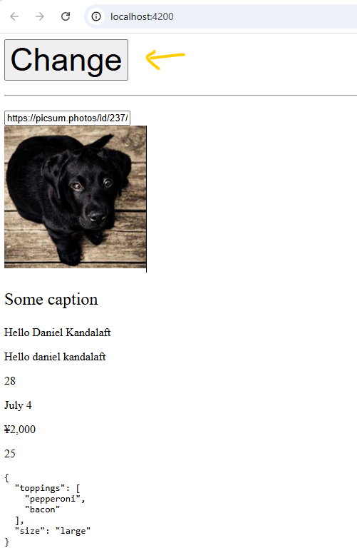

After making those changes, the button has enlarged. Angular is capable of updating our elements after they’ve been rendered. This is the power of directives. We have two directives for changing the appearance of an element. Angular gives us flexibility for interacting with elements.

In the next lecture, we are going to move on Structural Directives.